

S226 HIT339 DISTRIBUTED DEVELOPMENT

Individual Testing Documentation
TopEndLibraryHub | CSV Book Importer and Manager Reporting Exports
Prepared by:
Sandesh Bhattarai
Test date: 15 October 2026
Repository:
github.com/Kamal03102006/HIT339_Group8_TopEndLibraryHub
Feature branch:
feature/sandesh-csv-reports | Commit: 2ab17fa | Pull Request: #7

Contents
1. Responsibility 1
2. CSV Book Importer 2
3. Manager Dashboard and Exports 2
4. Implementation and GitHub Collaboration 3
5. Functional and Security Testing 3
6. Automated Fine Calculation Tests 4
7. Screenshot Evidence 4
8. Task and Hours Record 8
9. Strengths, Challenges and Learning 9
10. Value Added and Final Handoff 9

1. Responsibility
I wrote the CSV book importer, manager reporting dashboard and CSV/PDF report downloads for the Group 8 TopEndLibraryHub application. My work allowed administrators to input book data in bulk and gave authorised staff a clear overview of library stock, loans and fine totals. I also handled build and migration integration issues, checked access limitations, and added automated x Unit tests.

2. CSV Book Importer
The importer is built with ASP.NET Core MVC and Csv Helper for processing book records. The administrator chooses a library branch and uploads a CSV file and receives feedback about records that were imported and skipped. The importer validates mandatory information, checks for ISBN duplicates and provides a unique library code for every physical copy.
Field | Function
Title / Author / ISBN | Book identification and duplicate control
Category | Saved as Book Genre
Quantity | Creates separate physical copies, each with a unique code
Publication Year | Validated against supported year range
Publisher | Optional metadata
Selected branch | Assigns the imported copies to the selected library branch
The updated importer now enables multiple physical copies if the amount is larger than one. Early testing screenshots capture the initial implementation, and later tests and the updated interface reflect the modified behaviour for quantity and publishing year.

3. Manager Dashboard and Exports
The manager dashboard shows collection totals, availability, item condition, loan activity and recorded fines. Transit aware computation will not include products in transit in available stock. Managers can download the current summary as a CSV or PDF. The modified implementation adds paid and outstanding fine totals and loan level fine information into the report.
The dashboard uses library data rather than static sample statistics. The values updated as I was doing test loans and transfers. This means the display is showing the state of the local database.

4. Implementation and GitHub Collaboration
I built the features in feature/sandesh-csv-reports and submitted Pull Request #7 against the group repository. I fixed a shared .cs proj dependency conflict, fixed duplicate declaration of Branched, and updated the integrated migration so that the app may create and initialise its local database. The feature branch was updated from bb23ecf to da0f483 by the validated push, including the automated tests.
The project and separate test project build correctly under.NET 10. The team then can view the modifications via the feature branch and pull request and work to merge these back into the main branch.

5. Functional and Security Testing
ID | Scenario | Observed result | Status
TC01 | Bulk CSV upload | 100 books imported; 0 skipped | Pass
TC02 | Duplicate ISBN re-import | 0 imported; 100 skipped | Pass
TC03 | Invalid quantity of 0 | Record rejected: 1 skipped | Pass
TC04 | Missing CSV columns | Required-header validation displayed | Pass
TC05 | Catalogue integration | BK-0102 searchable and available | Pass
TC06 | Manager CSV export | CSV opened; source snapshot had 104 items | Pass
TC07 | Manager PDF export | PDF opened with matching summary figures | Pass
TC08 | Imported branch assignment | Read-only SQL check: BK-0102 at Darwin Hub, Branched 1 | Pass
TC09 | Unauthenticated CSV page | Redirected to login page | Pass
TC10 | Reception CSV permissions | Access Denied on direct /CsvImport request | Pass
TC11 | Future return date | Application rejected 2 Nov 2026; BK-0103 stayed active | Pass
TC12 | In-transit reporting | BK-0104 in transit; dashboard 103 available, 1 transit | Pass

6. Automated Fine Calculation Tests
I added TopEndLibraryHub.Tests as a separate x Unit project. The tests use the same $1.50 daily fine and payment-status expressions as the Loans Controller. The final execution completed with 8 tests passed, 0 failed and 0 skipped.
Test category | Cases | Result
Fine amount arithmetic | 0 days = $0; 1 day = $1.50; 4 days = $6; 8 days = $12 | 4 passed
Fine payment status | $6 unpaid; $6 paid; $0 treated as settled | 3 passed
Default x Unit test | Generated baseline test | 1 passed
These are isolated calculation tests, rather than end-to-end tests of non-zero fines being written to the database and included in CSV/PDF exports. The reporting screens observed during this work displayed $0.00 for the recorded, paid and outstanding fine balances.

7. Screenshot Evidence
The following images are from local functional testing. Initial import/export screenshots represent the earlier implementation; later screenshots show the integrated manager calculations and transfer workflow.
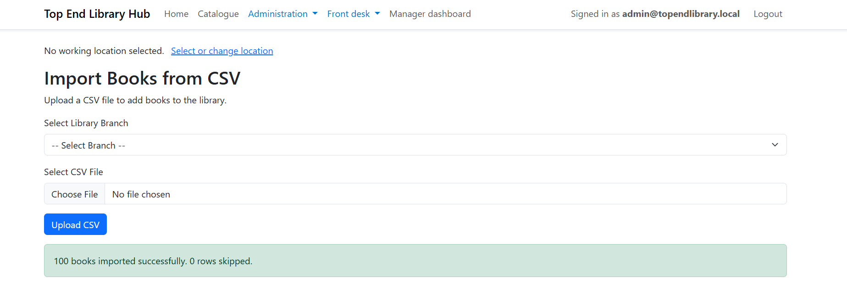
Figure 1. Initial bulk CSV test: 100 imports and no skipped rows.
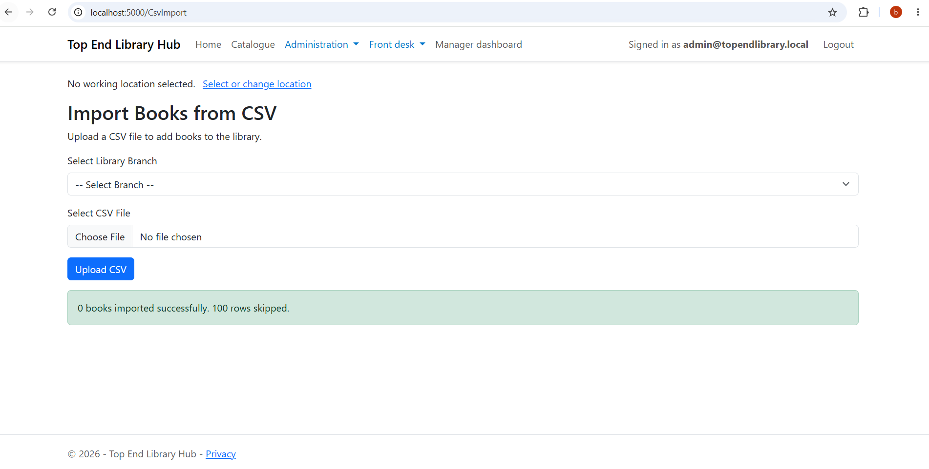
Figure 2. Duplicate CSV test: previously imported ISBNs skipped.
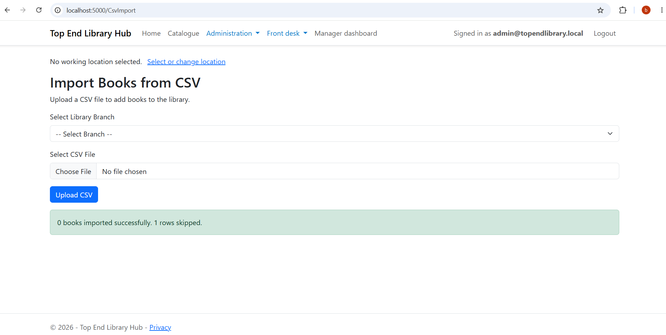
Figure 3. Invalid quantity validation.
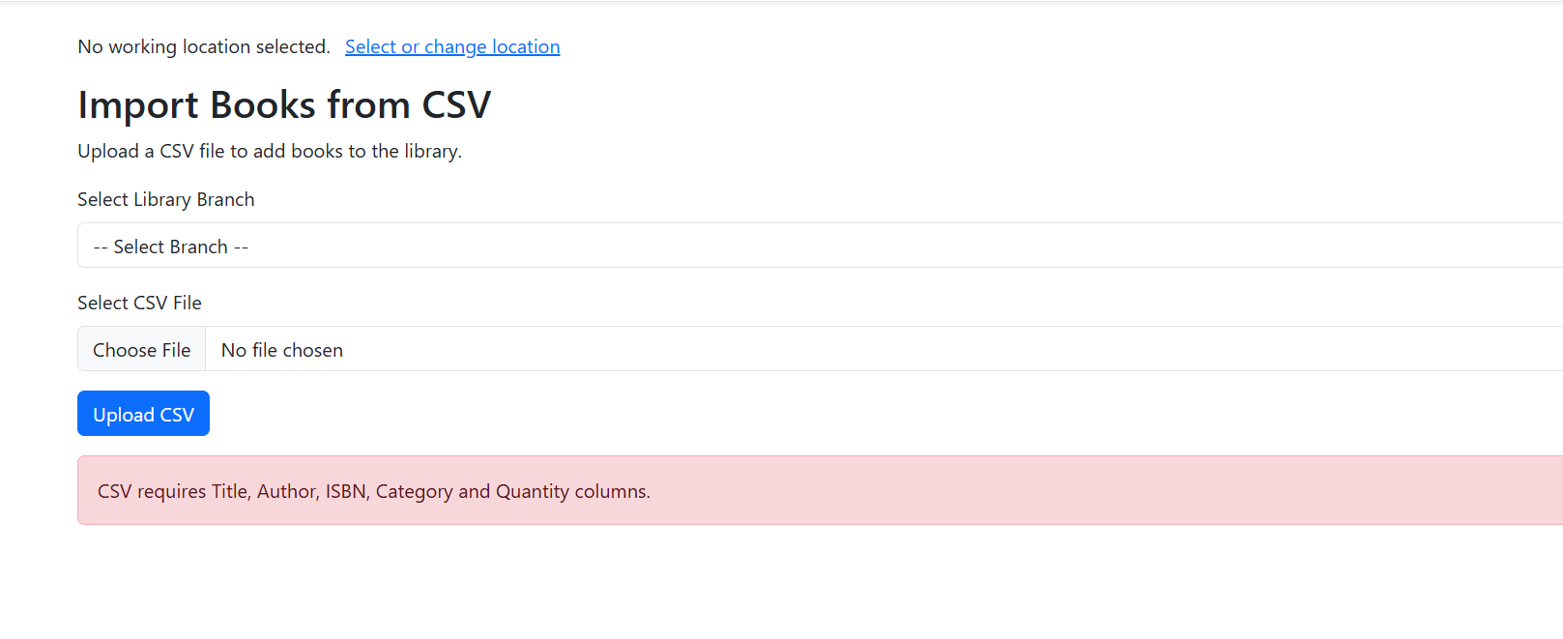
Figure 4. Missing-header validation.
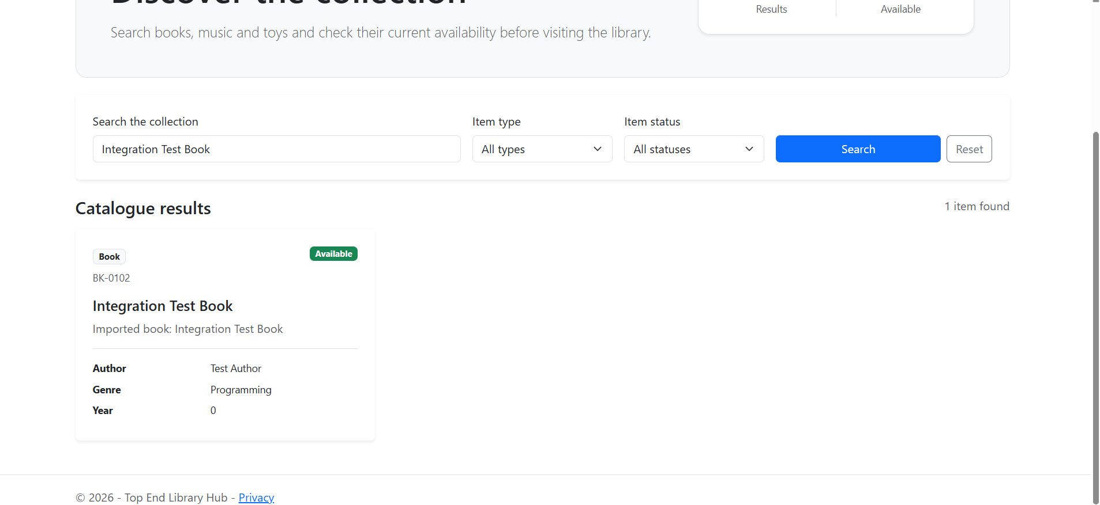
Figure 5. Catalogue search for BK-0102.
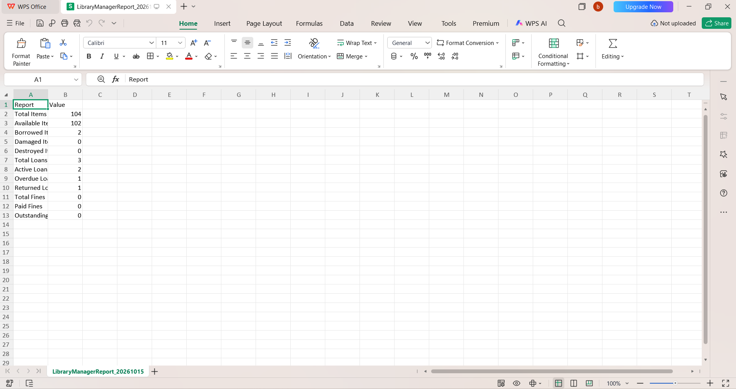
Figure 6. Manager CSV export opened successfully.
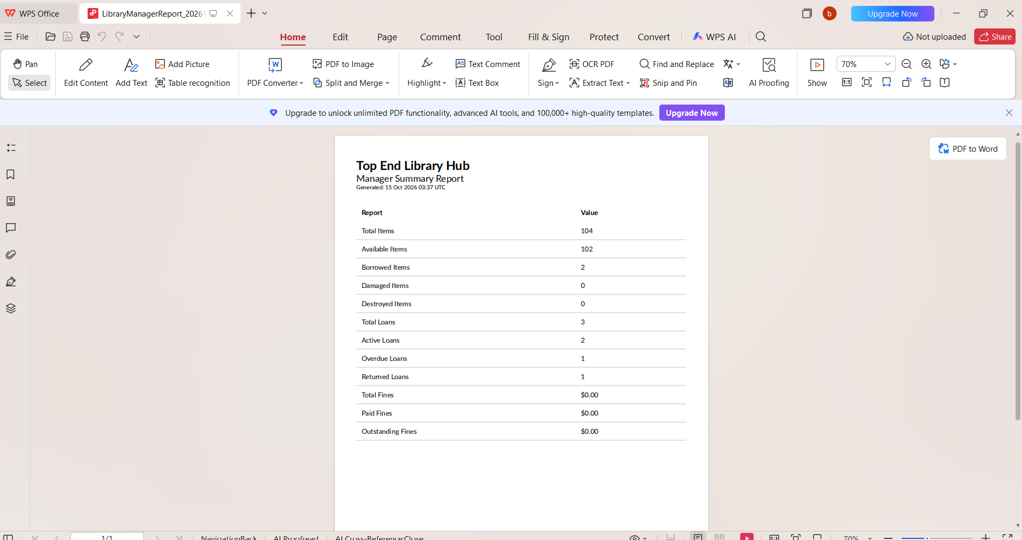
Figure 7. Manager PDF summary displayed.
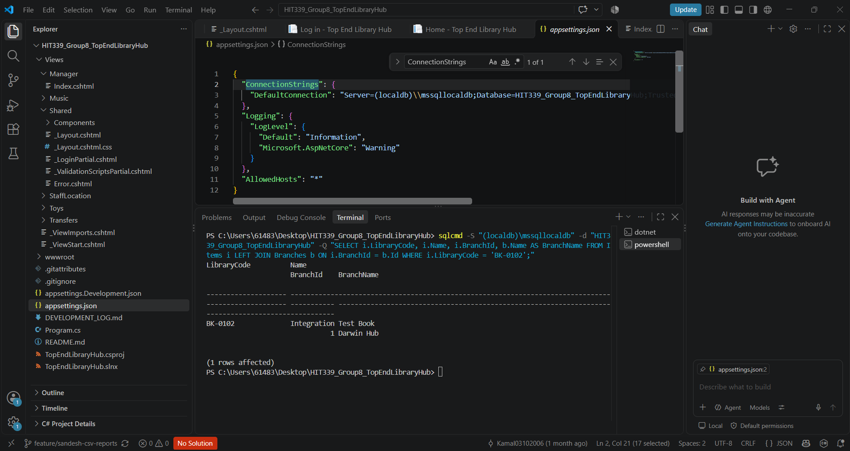
Figure 8. Read-only SQL verification of BK-0102 and Darwin Hub.
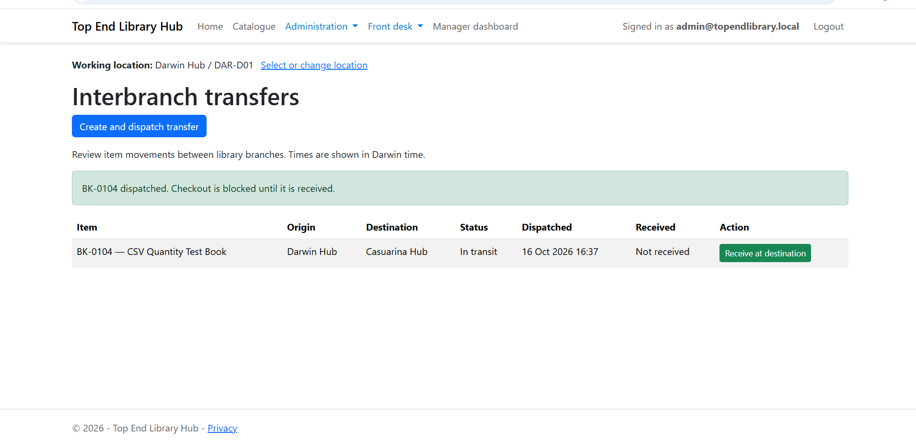
Figure 9. BK-0104 dispatched to Casuarina Hub within transit status.
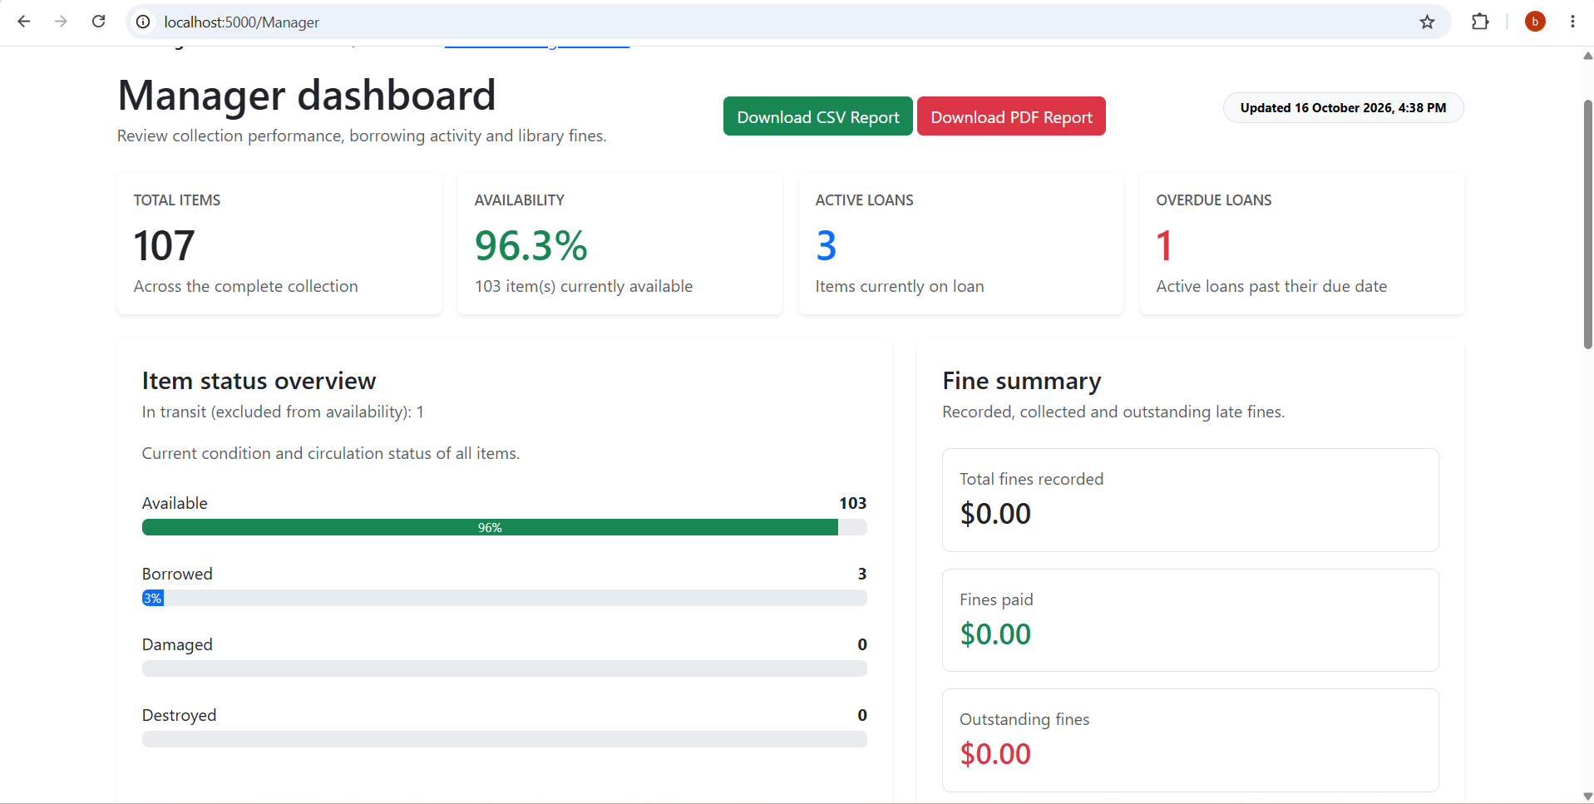
Figure 10. Manager dashboard: 107 items, 103 available and 1 in transit.

8. Task and Hours Record
The following figures are retrospective estimates based on project activities, not a contemporaneous timesheet. They should be adjusted if actual recorded hours differ.
Task | Estimated hours
Requirements review and team coordination | 2
CSV importer development | 5
Quantity, ISBN and publication-year improvements | 3
Manager dashboard and summary calculations | 4
CSV/PDF exports | 4
Database and migration troubleshooting | 4
Manual functional and access-control tests | 4
Automated x Unit testing | 3
GitHub commits, PR and conflict resolution | 3
Screenshots and report preparation | 3
Total estimated | 35

9. Strengths, Challenges and Learning
My primary strength was troubleshooting. The importer needed to be brought into the group project, which involved understanding the existing Book, Item, Branch and database models and changing field names and validation rules. I validated behaviour in the browser and verified using read-only SQL, not just successful compilation.
A big problem was dealing with shared code while teammates were upgrading branches, transfers and holds. I handled compiler difficulties, went through migration conflicts and checked that the programme still displays current catalogue records after database updates. I learnt more about ASP.NET Core MVC, Entity Framework Core, role-based authorisation, CsvHelper, QuestPDF, xUnit and GitHub pull requests.

10. Value Added and Final Handoff
My addition provides reusable manager reports for operational review and reduces laborious book input. The permission checks ensure that the CSV Import page is not accessible to unauthenticated users or to Reception users. The management data were also validated by excluding the in-transit copy from availability, after a transfer.
The deliverables include the reporting source code for the importer and manager, a separate automated test project, the contributions to the feature-branch, Pull Request #7, and this evidence-based report. The report makes a distinction between executed tests and code-review observations and does not consider an un-executed scenario as passed.

Repository:
https://github.com/Kamal03102006/HIT339_Group8_TopEndLibraryHub
Pull request: https://github.com/Kamal03102006/HIT339_Group8_TopEndLibraryHub/pull/7

